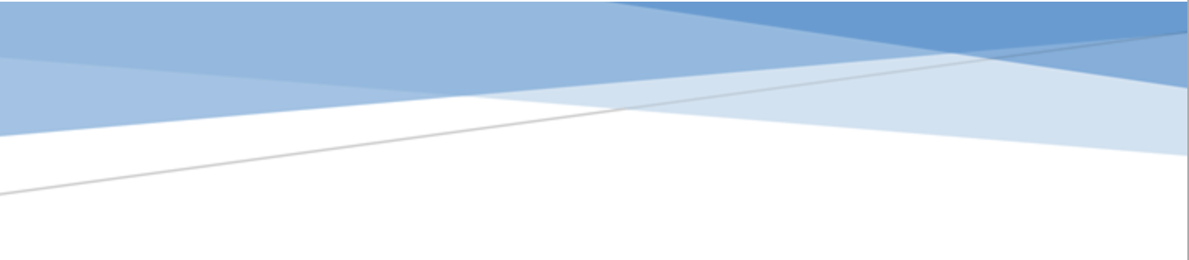



adges UI components library

**Component ID #1 – ex-map - v1.0.0**

## Document Control

## Version History

|  |  |  |  |
| --- | --- | --- | --- |
| Version | Date | Author | Reason for Change |
| **1.0.0** | 12/16/2019 | Wael Gomaa |  |
| **1.1.0** | 24/09/2020 | Rijin Mukundan |  |
|  |  |  |  |
|  |  |  |  |
|  |  |  |  |
|  |  |  |  |
|  |  |  |  |
|  |  |  |  |

## Review History

|  |  |  |
| --- | --- | --- |
| Version | Reviewer | Date |
|  |  |  |
|  |  |  |
|  |  |  |
|  |  |  |
|  |  |  |
|  |  |  |
|  |  |  |

Table of Contents

Document Control 2

Version History 2

Review History 2

1. Document and components Purpose. 4
2. General Information. 4
3. How to use. 4
4. Component features and configure. 6
5. How to configure component. 7
6. Examples 7

# 

# Document and components Purpose.

The purpose of the document is to guide how use and configure **ex-map** component.

# General Information.

Component Name: Map.

Extension Theme: ex-map.

Owner: Wael Gomaa.

Version no: v1.0.0

Design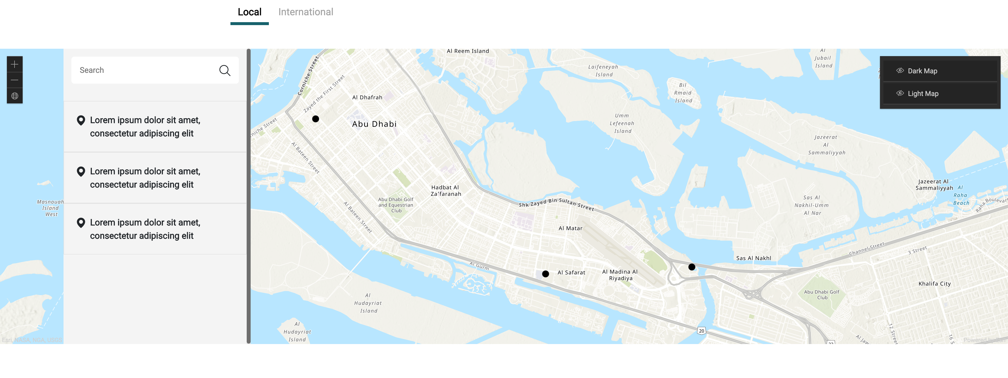

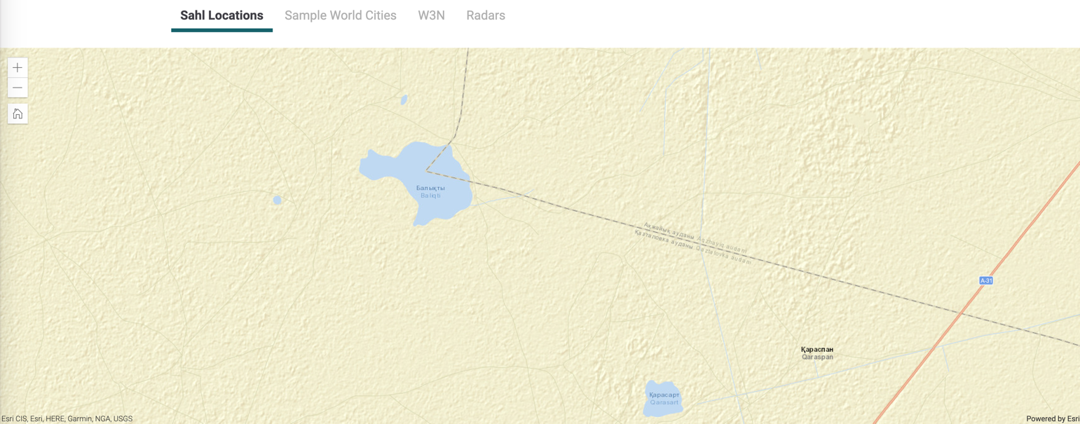

# How to use.

1. The available commands for this project .
   1. Compile : npm run gulp compile -- –path ex-map –extension
   2. Compile & include under ADGE tenant : npm run gulp compile -- –path ex-map –extension –full –dest [ADGEFolder]
   3. Deploy : npm run gulp deploy -- –path ex-map –extension
2. *Now project have full copy from this extension theme under the project theme and you can apply the project brand guideline and configure component based on project needs.*

# Component features and configure.

You have access now to configure component with the below item.

$map-tab-title-font-size : 20px !default;

$map-tab-title-line-height: 24px !default;

$map-tab-title-color : $grey-400 !default;

$map-tab-title-padding : 15px !default;

$map-tab-title-color-active : $grey-900 !default;

$map-tab-title-active-weight : bold !default;

$map-tab-title-active-line-color : #17626C !default;

$map-tab-title-active-line-height : 6px !default;

$map-search-box-font-size : 15px !default;

$map-search-box-bg : $grey-50 !default;

$map-search-box-width : 380px !default;

$map-search-box-left : 130px !default;

$map-search-box-bar-height : 90px !default;

$map-search-box-bar-input-bg : $white-color !default;

$map-search-box-bar-input-border-color : $white-color !default;

$map-search-box-bar-input-border-radius : 6px !default;

$map-search-box-bar-icon-position : 0 !default;

$map-search-box-bar-icon-width: 55px !default;

$map-search-box-item-color: $grey-600 !default;

$map-search-box-item-font-size : 12px !default;

$map-esri-zoom-esri-widget-border-color:color-opacity($grey-700,0.3) !default;

$map-map-box-bg : $grey-300 !default;

$map-map-box-height : 600px !default;

$map-map-box-popup-radius : 20px !default;

$map-map-box-popup-text-align: center !default;

$map-map-box-popup-font-size : 20px !default;

$map-map-box-popup-padding : 1rem !default;

$map-map-box-popup-line-height : 26px !default;

$map-map-box-marker-color : #17626C !default;

# How to configure component.

1. **Adding Built-In or Bootstrap Class (on the variant)**
   1. Spaces, Font weights, Display, Position properties etc can be added by bootstrap classes
      1. i. Spacing: <https://getbootstrap.com/docs/4.0/utilities/spacing/>
      2. ii. Flex: <https://getbootstrap.com/docs/4.4/utilities/flex/>
      3. iii. Font: <https://getbootstrap.com/docs/4.0/content/typography/>
   2. These classes should only be added to match the design
   3. For built-in classes check 7 Below to see the entire list
2. **SCSS Variable Override (on the _override.scss file)**

To configure the component we can take the above variables from section **4. Component features and configure** and add them to: adge-ph2/themes/<ADGE>/vars/_override.scss, this file with your desired changes to match the design.

1. **Complete style override**
   1. This should be the last and final option if the above 3 didn’t get you the desired output
   2. This is overwriting the SCSS of the component by adding your own style to it
   3. **Note: Take permission before doing this override**
   4. Instructions:
      1. Open the file /adge-ph2/themes/<ADGE>/sass/overrides.scss and add your own SCSS styles to override the faulty component.

# Dependencies

components-accordion.css

components-map.css

smooth-scrollbar-min.js

scrollbar-init.js

components-accordion.js

https://js.arcgis.com/4.14/esri/themes/dark/main.css

https://js.arcgis.com/4.14/

components-map.js

# Examples

Examples1:

I need to change text color.

I’ll copy the below variables from extension theme.

$highlight-main-tittle-color: $primary-color;

Then will paste the above variable in project folder theme in file _custom.scss and change with any variable based on site needs.

$highlight-main-tittle-color: $secondary-color;

Examples2:

I need to the button shape from square to had a rounded corner.  
I’ll copy the below variables from extension theme.

$button-shape-square: $border-radius-value;

$border-radius-value: 0px;

Then will paste the a above variable in project folder theme in file _custom.scss and change with any variable based on site needs.

$button-shape-square: $border-radius-value;

$border-radius-value: 20px;